# Using the Sinkala Cell

James E. McCutcheon, Dept. of Neuroscience, Psychology & Behaviour, University of Leicester, UK

## 1. Intro

The ability to calibrate carbon fibre electrodes used in electrochemical techniques such as fast-scan cyclic voltammetry is essential. Calibrations allow redox currents measured *in vivo* or *in vitro* to be converted into concentration of a particular chemical species. Several years ago, we developed a simple microfluidic flow cell based on a principles of laminar flow (Sinkala et al., 2012) to allow calibrations to be easily conducted; as testament to its utility, the flow cell has been adopted by several other research groups (Badrinarayan et al., 2012; Vander Weele et al., 2014; Pei et al., 2016; Resendez et al., 2016). However, since its initial introduction, we have made several alterations to the design and operation of the cell, which make it accessible for a wider population of end-users. In particular, this has involved adapting the flow cell so that users working with bare electrodes (i.e. electrodes not housed in *in vivo* micromanipulators) are able to use it. As these processes were not included in the original paper (Sinkala et al., 2012), in the following document we provide an updated account detailing how to effectively set-up and use the Sinkala Cell.

## 2. Fundamentals of the Sinkala Cell

The cell comprises of two parts which, when joined together using the screws, has four Luer-style openings and one smaller (1 mm) hole. The aperture through which electrodes are introduced to the cell depends on whether the electrodes to be calibrated are housed in *in vivo*-style micromanipulators: electrodes in manipulators can be lowered via the smaller hole whereas electrodes not housed in manipulators are introduced via the larger hole. There are two Luer inlet holes on the top of the flow cell for buffer and test solution and the single Luer hole on the side is an outlet. Gravity flow is the preferred method for delivering solutions to the cell. A reference electrode can be added either to the Luer outlet on the side or the hole on the top only if it is not being used to introduce the working electrode.

## 3. Setting up the cell

### 3.1 Position of cell

The cell should be placed in a container that is larger than the cell and approximately the same depth as the cell’s height. A deep petri dish or pipette box lid works well. The cell needs to be fairly secure so that it and the dish will not easily move during operation. Options for securing the cell include fixing magnets to the cell with super glue and performing experiments on a magnetic surface or using putty/Blutak.

### 3.2 Delivering solutions

Syringes (Luer-Lock 60 mL) with plungers removed and elevated approximately 50 cm above the cell are used to deliver solutions. To elevate syringes, we have used either retort stands or a centrifuge tube holder fixed to a shelf (e.g. VWR, [#60916-101](https://us.vwr.com/store/catalog/product.jsp?catalog_number=60916-101)). Intravenous-style (IV) regulators are used to control flow of solutions. One-way Stopcocks should be attached to the syringes and to the inlet ports on the flow cell. Tubing (e.g. Tygon R6303, ID, OD) should connect these together via the IV-style regulator. Additional Luer fittings will be required to make connections (e.g. male Luer fittings for 1/16” ID tubing, WPI, [#13160](https://www.wpiinc.com/products/laboratory-supplies/13160-100-male-luer-fitting-for-1-16-id-tubing/?query=%28category.ne.test%29.and.%28%28name.like.13160.or.misc0.like.13160.or.misc2.like.13160.or.misc3.like.13160.or.misc4.like.13160.or.misc5.like.13160.or.misc6.like.13160.or.misc7.like.13160.or.misc8.like.13160.or.misc9.like.13160%29%29&xsearch_id=products_search_all&xsearch%5b0%5d=13160&back=products)).

### 3.3 Introducing electrodes

The process of delivering electrodes differs depending on the type of electrode and individuals may wish to customise the process further to suit their lab environment, work-flow etc. Thus, the following procedures are intended as a guide. However, for both types of electrode it is recommended that electrodes are not introduced until after the flow cell has been primed with solution(s) (Step 9 in Section 4: Operation of the cell).

#### 3.3.1 Manipulator-housed electrodes

Many labs using voltammetry house electrodes for *in vivo* use micromanipulators that are designed to interface with BASi guide cannulas. The Sinkala Cell was originally designed to allow these electrodes to be introduced directly into the microfluidic channel. Manipulators should be prepared by recessing electrodes by three turns into the body of the manipulator, as is usual when using manipulators for *in vivo* experiments. The manipulator is then inserted into the ‘key’ on the top of the flow cell above the small hole. The electrode is then lowered via the manipulator until it is in the channel. The exact number of turns should be determined by the user as it will differ for each individual flow cell due to small differences in their height. The number of turns can be determined in two ways: (i) by introducing the electrode into the top block of the disassembled flow cell and counting the number of turns before the electrode emerges from the small hole; or (ii) counting the turns before an electrode is deliberately broken by driving the electrode into the bottom of the channel. Importantly, the kinetics of the response detected by the electrode (i.e. rise and fall) rely critically on the electrode being fully inserted into the channel; slow onset and offset of responses are often fixed by advancing the electrode.

#### 3.3.2 Bare, non-housed, electrodes

Bare electrodes are introduced via the large Luer-style opening near the side outlet hole. Electrodes need to be held securely in a way that allows fine control in the vertical axis. Options include a stereotaxic frame, a patch-clamp style micromanipulator, or a custom solution. In Appendix II, we outline the custom solution that we have devised that uses parts readily available from Thor Labs and Narishige.

Electrodes held in a manipulator should be lowered into the large opening. Once a signal is detected on the recording apparatus, signifying that the electrode is in contact with solution, electrodes should be advanced a set distance to aid in replicability. For example, with our custom manipulator, we advance electrodes a further three turns, but individuals may wish to determine their own procedure.

### 3.4 Reference electrode

A reference electrode is constructed from a gold pin, a length of silver wire (Sigma) and a Luer fitting. The Luer fitting is cut away with a scalpel, which allows solution to flow past when the reference is plugged into the side outlet port. After construction the silver wire should be cut to correct length and chlorided, for example, using a 9 V battery and 1 M HCl.

### 3.5 Additional equipment

A 60 mL syringe attached to length of tubing is useful for removing excess solution from the petri dish as it fills up and from the solution reservoirs if they requiring changing.

### 3.6 Solutions

One consideration is that buffer solution used will affect the electrochemical responses recorded in flow cell. For example, oxidation peak for dopamine changes from ~+0.54 V to ~+0.62 V when calibrated in phosphate buffered saline vs. aCSF.

Another important consideration is that temperature changes will have large effects on electrode responses therefore it is essential that buffer and analyte solutions are applied at identical temperatures. For this reason, we keep buffer solution at room temperature, which is why no sugars are included. We use an aCSF recipe with the following constituents (note the lack of glucose): in mM, 125 NaCl, 4 KCl, 1.3 CaCl2, 1 MgCl2, 2 Na2HPO4, 0.66 NaH2PO4. Additional instructions are included in Appendix III.

Dopamine, which is the most common analyte we test, degrades in solution due to oxidation, which can lead to poor calibrations. We therefore adhere to the following policy. A fresh 10 mM dopamine hydrochloride stock (in dH2O) is made up fresh daily and kept at 4°C until required. Dilutions of this stock in buffer (e.g. 1 µM and lower) are made up and used in the flow cell for no longer than 1 h. Dopamine stocks that have been frozen have yielded poor results in our hands.

## 4. Operation of the cell

1. With stopcocks closed, add ~50 mL to syringes: buffer (syringe 1) and buffer + analyte (e.g. 1 µM dopamine; syringe 2).
2. Turn IV regulators attached to both syringes to maximum (‘Open’)
3. With tubing coming from syringe 1 directed into a waste beaker, not the flow cell, open the stopcock and allow buffer to flow through tubing. Try to eliminate any bubbles and then turn IV regulator until flow is reduced to approximately 1-2 drops per second. Close stopcock.
4. Repeat step 3 with syringe 2.
5. Open both stopcocks and by watching drops of each solution at the same time, make small adjustments of IV regulators until flow rate is equal.
6. Close both stopcocks and plug connectors into flow cell inlets.
7. Open both stopcocks from each syringe simultaneously. Solution should flow through the cell and out of the outlet without creating any bubbles in channel.
8. Close stopcock from syringe 2 (analyte) and lower flow rate of syringe 1 (buffer; approx. 100 mL/h)
9. Working electrodes should be introduced to cell as described in Section 3.3.
10. Response at electrode can be tested by simultaneously turning on stopcock attached to syringe 2 (analyte) and turning off syringe 1 (buffer).

## 5. Troubleshooting

The most common problems users have encountered are as follows:

### 5.1 Solution does not flow through the Y-channel.

Possible cause/solution: the cell is screwed together the wrong way.

When assembling the cell, ensure that the inlets correspond to the Y of the Y channel and not the stem of the Y. If the cell is screwed together the wrong way no solution will be able to flow through the channel.

### 5.2 A bubble or bubbles are trapped in the channel.

Possible cause/solution: solutions were not introduced simultaneously.

If the flow of solutions is not started simultaneously after first equalizing their rates then it is likely a bubble will be trapped. Only solution is to take the cell apart and repeat Steps 3-7.

### 5.3 Background signal fluctuates by a large amount.

Possible cause/solution: Fluid level may be fluctuating.

Occasionally, the level of fluid will ‘pulse’ and, if an electrode is introduced to the large outlet hole, this may cause the length of fibre exposed to the solution to change, leading to the background signal fluctuating. One option is to advance the carbon fibre. Another option is to try to prevent the pulsing by raising the level of solution in the large dish.

### 5.4 Electrochemical signals are noisy and analyte does not look as expected.

Possible cause/solution: check that the analyte made correctly.

It is essential that the analyte is made up in buffer, not water. Accurate electrochemical detection of an analyte requires that the *only* difference between the two solutions being fed into the flow cell is the analyte of interest (e.g. dopamine). Stock solution can be made in water (e.g. 10 mM) but all dilutions need to be made in buffer. In addition, analytes such as dopamine may degrade quickly. Ensure that stock is made daily and kept in the fridge (or on ice in the dark). Only use dilutions for 30-60 minutes before making a fresh dilution.

### 5.5 Electrochemical signals have slow kinetics

Possible cause/solution: Electrode is too far from channel.

This is more commonly a problem when electrodes are being introduced using an in vivo micromanipulator as solution flow up the small hole is minimal. Advancing the electrode should help.

## 6. References

Badrinarayan A, Wescott SA, Vander Weele CM, Saunders BT, Couturier BE, Maren S, Aragona BJ (2012) Aversive stimuli differentially modulate real-time dopamine transmission dynamics within the nucleus accumbens core and shell. J Neurosci 32:15779–15790.

Pei Y, Asif-Malik A, Hoener M, Canales JJ (2016) A partial trace amine-associated receptor 1 agonist exhibits properties consistent with a methamphetamine substitution treatment. Addict Biol:1–11.

Resendez SL, Keyes PC, Day JJ, Hambro C, Austin CJ, Maina FK, Eidson LN, Porter-Stransky KA, Nevarez N, McLean JW, Kuhnmuench MA, Murphy AZ, Mathews TA, Aragona BJ (2016) Dopamine and opioid systems interact within the nucleus accumbens to maintain monogamous pair bonds. Elife 5.

Sinkala E, McCutcheon JE, Schuck MJ, Schmidt E, Roitman MF, Eddington DT (2012) Electrode calibration with a microfluidic flow cell for fast-scan cyclic voltammetry. Lab Chip 12:2403–2408.

Vander Weele CM, Porter-Stransky KA, Mabrouk OS, Lovic V, Singer BF, Kennedy RT, Aragona BJ (2014) Rapid dopamine transmission within the nucleus accumbens: Dramatic difference between morphine and oxycodone delivery. Eur J Neurosci 40:3041–3054.

# Appendix I: Custom manipulator

## Parts required:

|  |  |  |  |
| --- | --- | --- | --- |
| Name of part (all from Thor Labs) | Imperial # | Metric # | Quantity |
| Heavy-Duty Magnetic Base | MB175 | MB175/M | 1 |
| Mini-Post Right-Angle Post Clamp | MSRA90 | MSRA90 | 2 |
| Ø1/2" Translating Post Holders | PH3T | PH3T/M | 1 |
| Ø1/2" Stainless Steel Optical Posts | TR1.5 | TR30/M | 1 |
| Mini-Series Thread Adapters | AP8E4E | AP4M3M | 1 |
| Mini-Series Ø6 mm Diameter Posts | MS1.5R | MS1.5R/M | 1 |
|  |  |  |  |

Missing: Ø6 mm stainless steel rod, length = 12 cm.

Electrode holders in this set-up are 6 mm stainless steel rods with custom attachments that allow electrodes to be held securely. For glass electrodes, we use a custom electrode holder made by our workshop, which is based on a part from Narishige (left). For silica-based electrodes, we use a custom electrode holder made in our lab using some polyimide tubing and a socket (right).

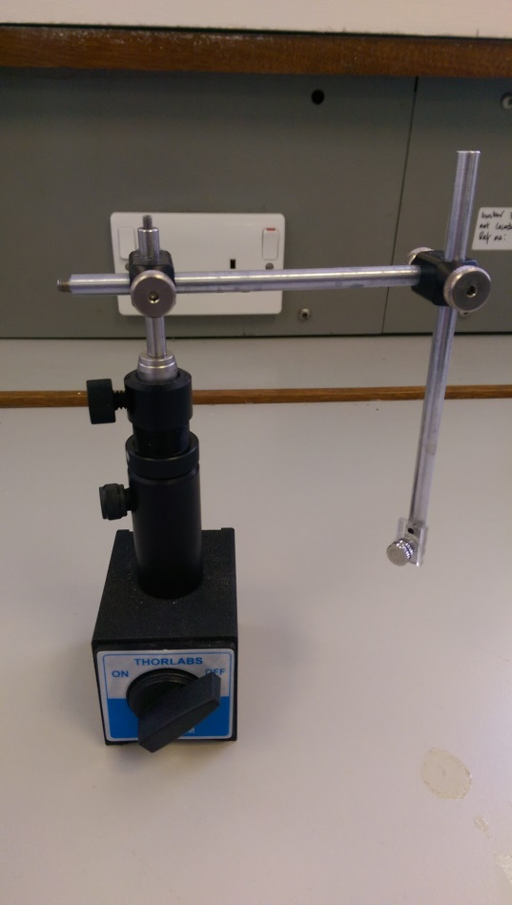 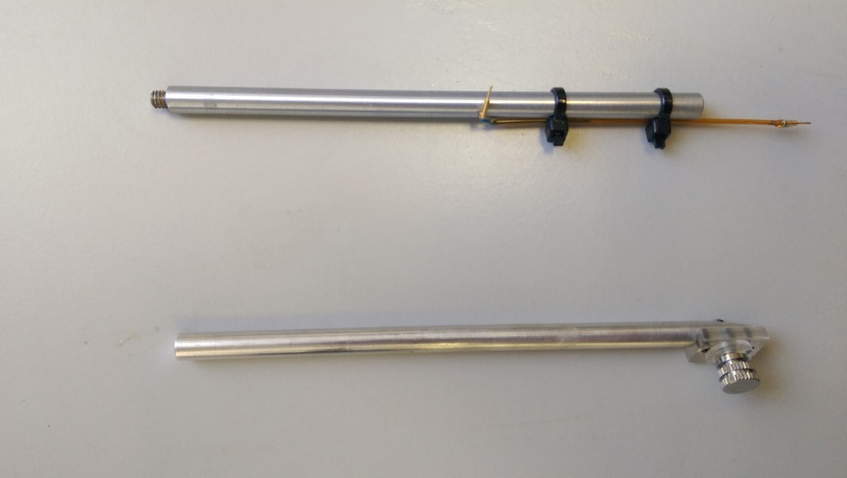

# Appendix II: Constructing reference electrodes

## Parts required:

* Silver wire (#327026-20G, Sigma)
* Gold pin (#82K7797, Newark)
* 5 minute epoxy (NC9987160, Fisher)
* Luer fitting (for 1/16" ID Tubing, #13160; WPI)
* HCl (for chlorinating)

## Instructions:

* Insert a length of silver wire (~30 mm) into a gold pin and epoxy in place.
* Make cut away on Luer fitting using razor blade.
* When dry, pass wire through small hole in Luer fitting and trim excess wire so that it does not protrude from Luer.
* Remove reference from Luer and chlorinate silver wire with 9 V battery and 1 M HCl.
* Pass reference back through Luer fitting and epoxy in place.

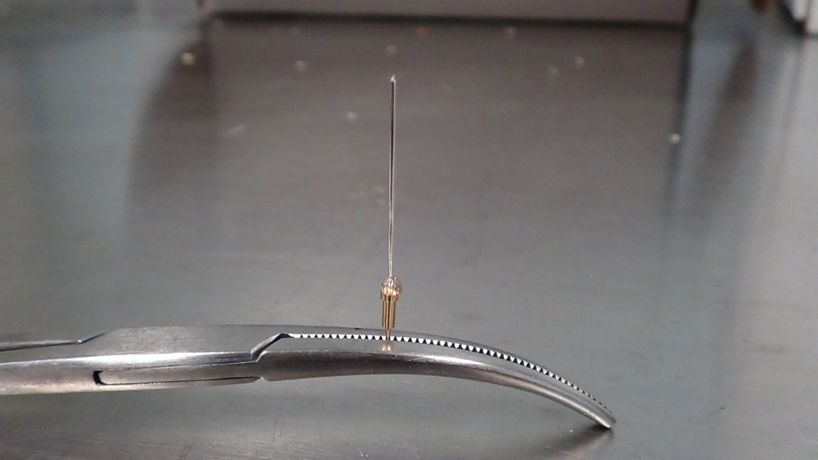

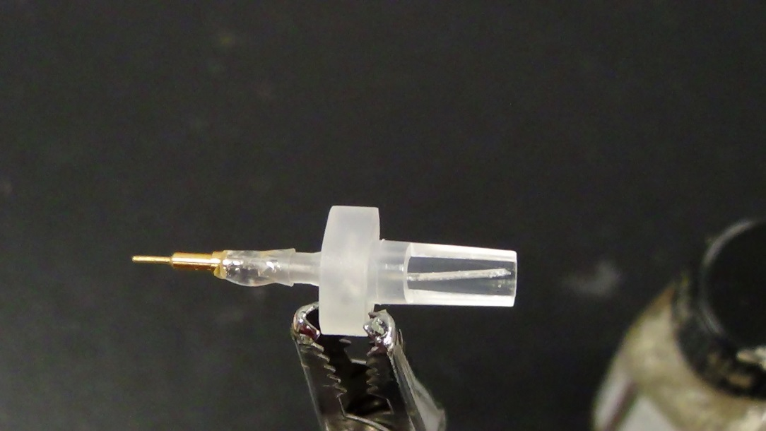

# Appendix III: aCSF

* Make stock solution for each component except NaCl (e.g. 40 mL of each, keep in Falcon tubes).
* For 1 L of aCSF add NaCl (7.3 g) to ~900 mL dH2O.
* Add 4 mL of each stock solution.
* Top up volume to 1 L with dH2O.

|  |  |  |  |
| --- | --- | --- | --- |
|  |  | final molarity (mM) | stock molarity (M) |
| NaCl | sodium chloride | 125 | n/a |
| KCl | potassium chloride | 4 | 1 |
| CaCl2 | calcium chloride | 1.3 | 0.325 |
| MgCl2 | magnesium chloride | 1 | 0.25 |
| Na2HPO4* | sodium phosphate dibasic | 2 | 0.5 |
| NaH2PO4 | sodium phosphate monobasic | 0.66 | 0.165 |

* stock cannot be kept in fridge